- Create instance and check the connectivity by ec2 instance.

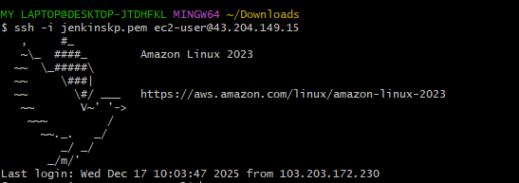

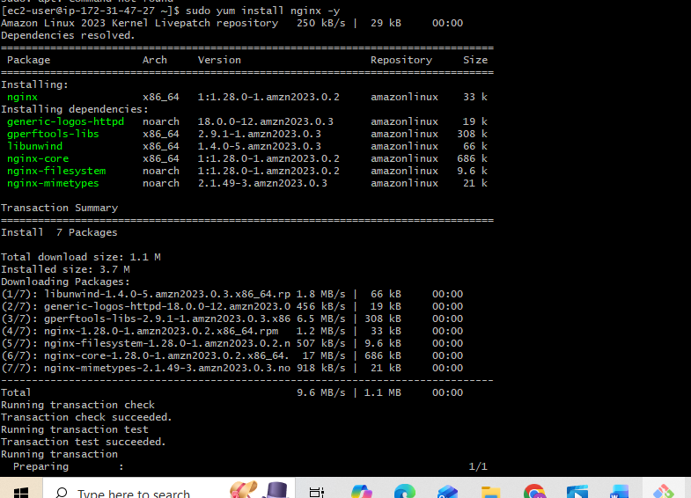
Sudo yum install nginx -y

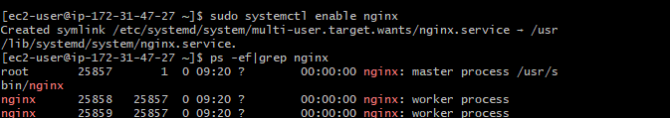
sudo systemctl status nginx
systemctl start nginx
systemctl enable nginx
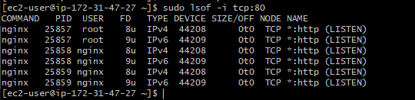
check on which port nginx is running by default it is on port Number:80 Command: sudo lsof -i tcp:80

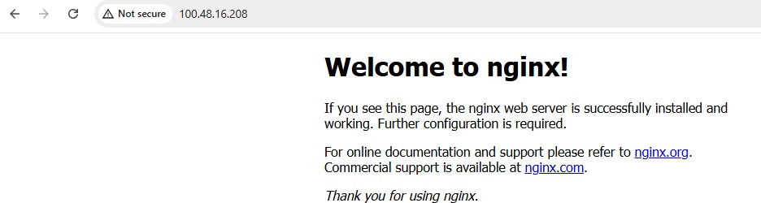
Step5: On browser give ip address of ec2 instance and port number of nginx. It is Running on default port Number:80
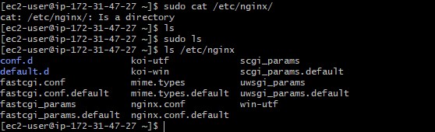
Step 6: ls /etc/nginx is command for to check downloaded files in nginx.

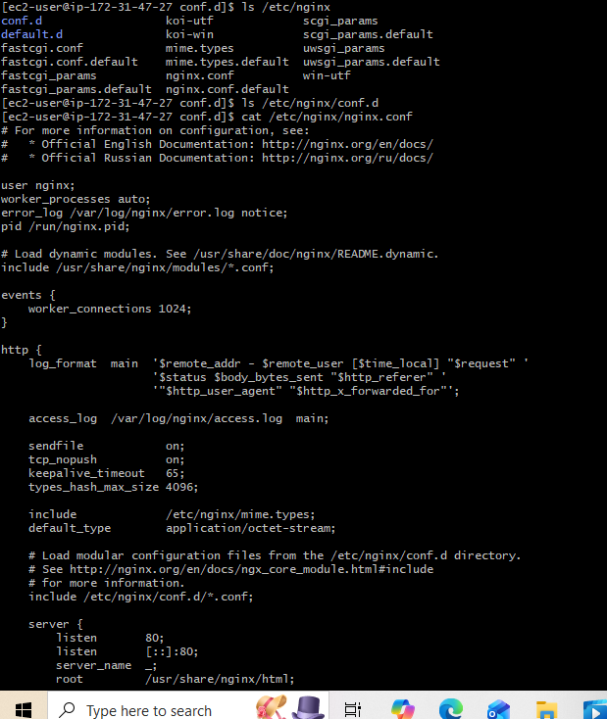
Step 7:cat /etc/nginx/nginx.conf command to read configuration file.

Step 8: Before editing configuration file we have to take backup for safer side. Command is sudo cp /etc/nginx/nginx.conf /etc/nginx/nginx.conf.back

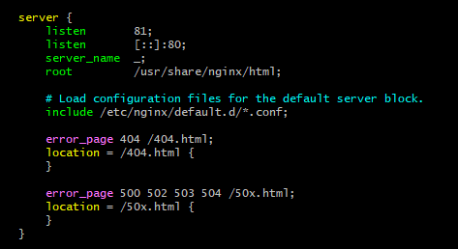
Step 9: create file name as nginx.conf and copy the content configuration file from backup file and edit according to our convenience and save it.
- sudo nginx -t syntax is ok
test is successful Restart nginx
- sudo systemctl restart nginx
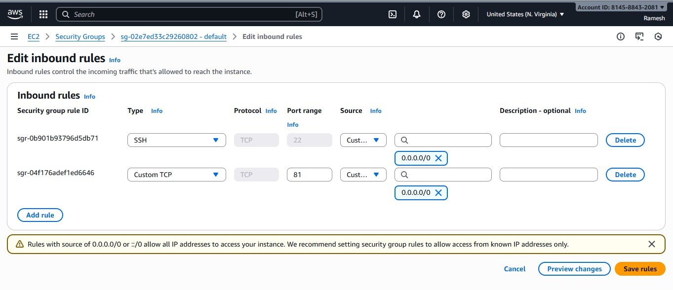
- sudo systemctl status nginx

Step 10:Edit inbound rules add rules in it by port number by 81.

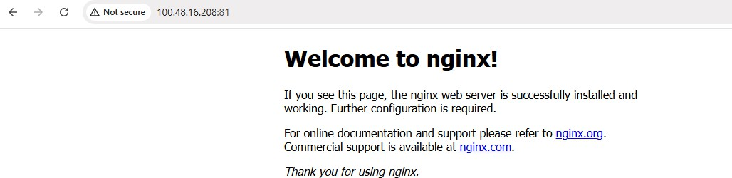
Step 11: Browser it by ec2 ip address and port num as 81.

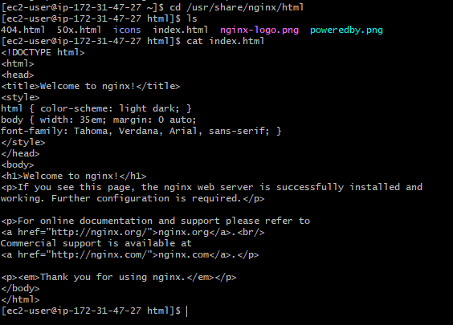
- Deploy a sample index.html file on nginx.
Step1: cd /usr/share/nginx/html
  - Check ls command for files present /usr/share/nginx/html path.
  - Cat index.html to view the content of webpage
Step 2: sudo vi /usr/share/nginx/html/index.html to edit the webpage.

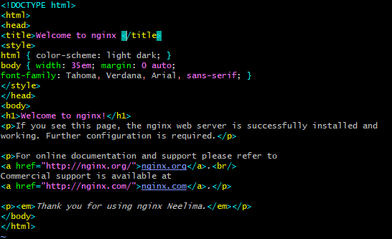
Step3: Editing can be done here and after editing as per required then save it by esc
:wq!
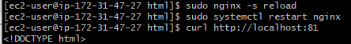
Step 4:
  - sudo nginx -s reload
  - sudo systemctl restart nginx
  - curl http://localhost:81
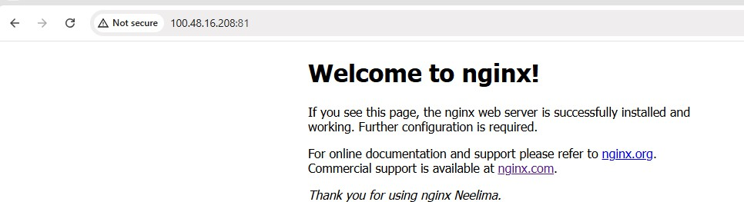
After editing file of index.html we have to run these commands.

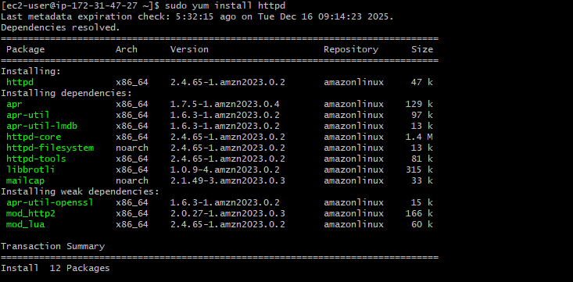
- Install Apache and run Apache on port number 82

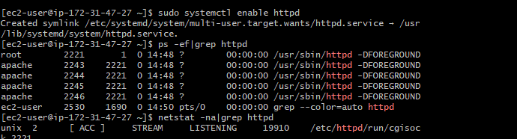
Step 1: Sudo yum install httpd

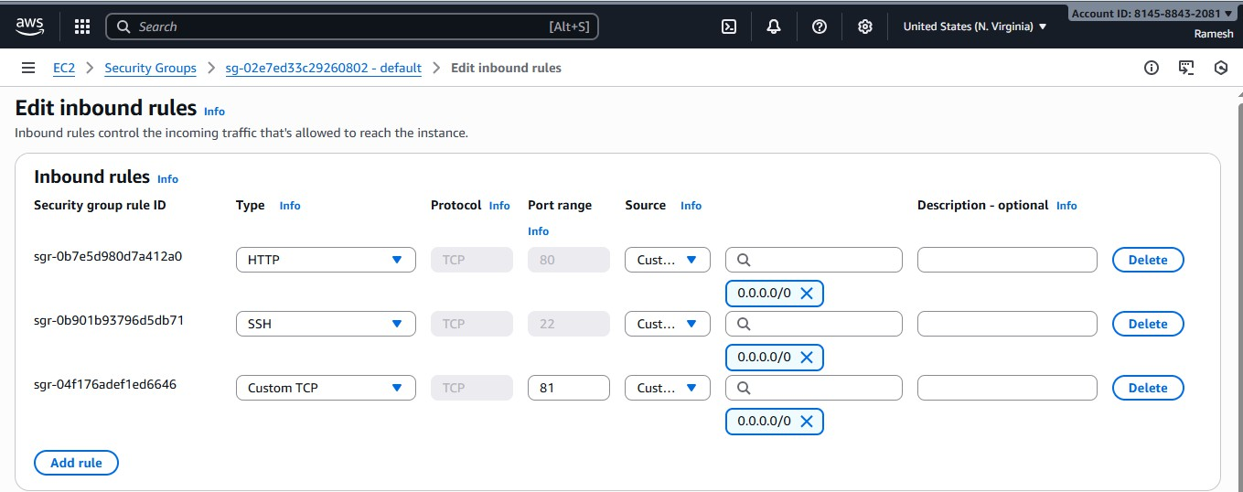
Step 2: sudo systemctl enable httpd.

Step 3:EC2→Security groups→sg default -→Edit inbounded rules Add rules and
insert port range and save it.

Step 4: Browser with IP address of Ec2 instance with port range.
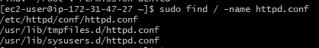

Step5: sudo find /-name httpd.conf
- We find /etc/http/conf/httpd.conf
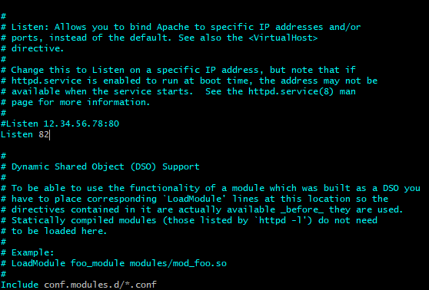
- Before Editing any configuration we should take backup for safer side.

Step 6: change port number 82 according to us and save it.

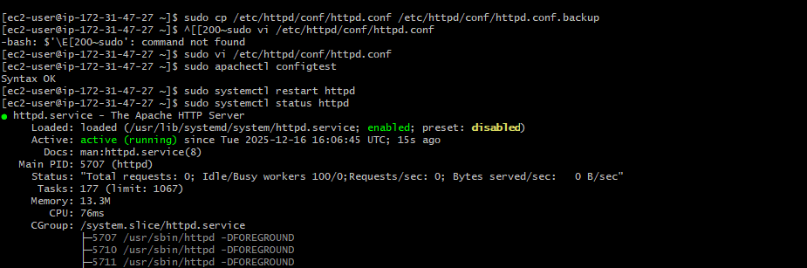
Step 7:Sudo apachectl configtest
- Sudo systemctl restart httpd
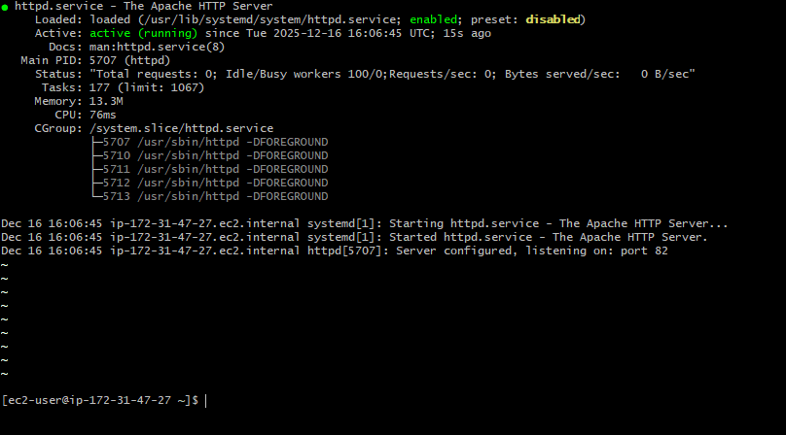
- Sudo systemctl status httpd

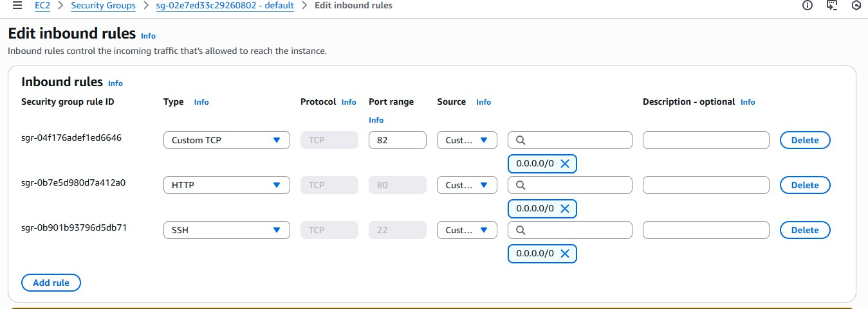
Step 8: Ec2 -> Security groups->sg—default→Edit inbound rules according to the changes required for us.

Step 9:Browse with ip address od instance with port 82.

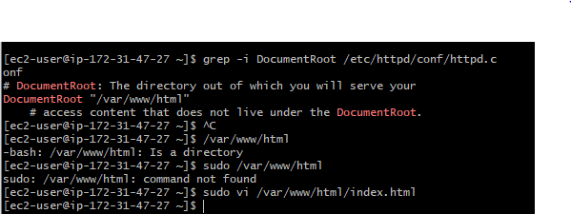
- Deploy a sample index.html file on Apache.
Step 1: Var/www/html default path for deploy of own website.
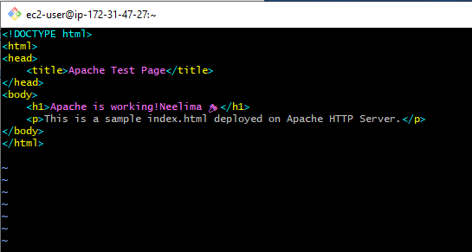
step 2: sudo Vi /var/www/html/index.html Add changes to it and save it.

Step 3: Browser with Ip address of instance with port number.

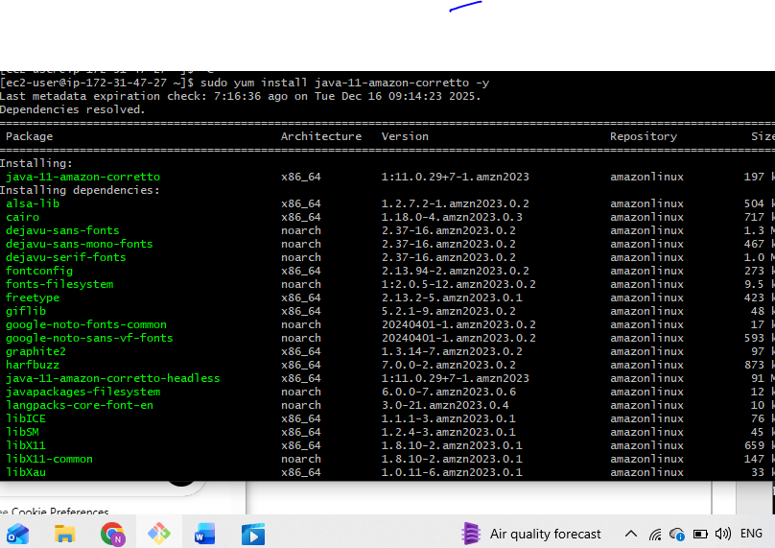
- Install Apache tomcat on port number 8082
Step1: sudo yum install java-11-amazon-corretto -y
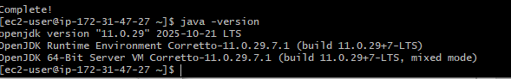
Step2: java -version
Step 3:readlink -f /usr/bin/java

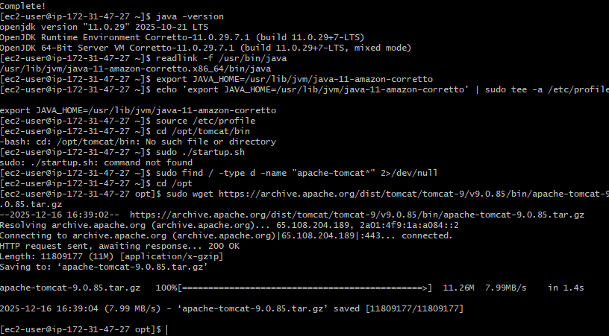
/usr/lib/jvm/java-11-amazon-corretto.x86_64/bin/java Export JAVA_HOME=/usr/lib/jvm/java-11-amazon-corretto
Echo ‘export JAVA_HOME=/usr/lib/jvm/java-11-amazon-corretto’|sudo tee -a /etc/profile Export JAVA_HOME=/usr/lib/jvm/java-11-amazon-corretto
Source /etc/profile Cd /opt/tomcat/bin
Sudo ./startup.sh [If we are getting error give permissions] Sudo find / -type d -name “apache-tomcat*” 2>/dev/null Sudo wget link for tomcat download
Extract file and check connected

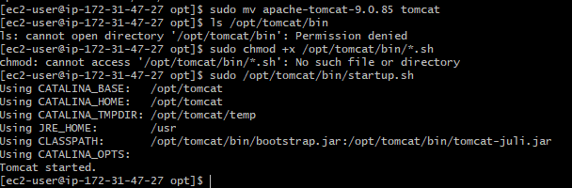
Step 4: sudo mv apache-tomcat-9.0.85 tomcat (Taking backup)
- ls /opt/tomcat/bin[ if we are getting error give permission]
- sudo chmod +x /opt/tomcat/bin/*.sh
- sudo /opt/tomcat/bin/startup.sh

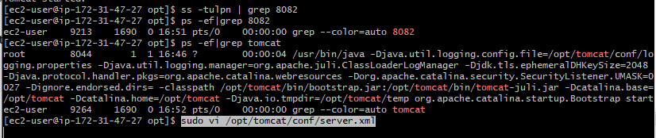
- Step 5: ss -tulpn |grep 8082
- Sudo ps -ef|grep 8082
Or
- Sudo ps -ef|grep tomcat
- Sudo vi /opt/tomcat/conf/server.xml
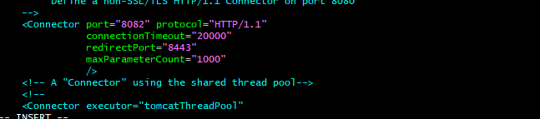
Step 6: if we want any changes in server.xml we have edit it. Here we are changing port number 8080 to 8082.

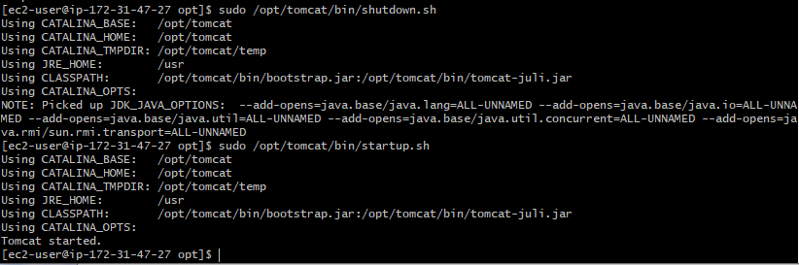
Step 7:sudo /opt/tomcat/bin/shutdown.sh sudo /opt/tomcat/bin/startup.sh
Tomcat started.
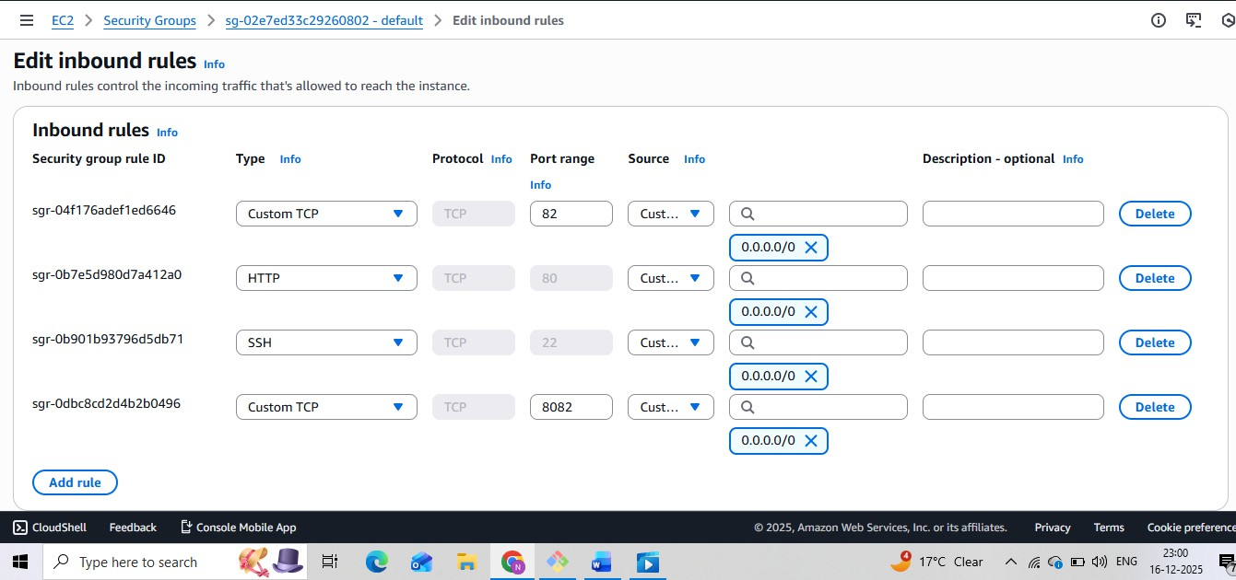
Step 8: ec2->security groups -> sg---default-→edit inbound rules Change port to 8082 and save rule.

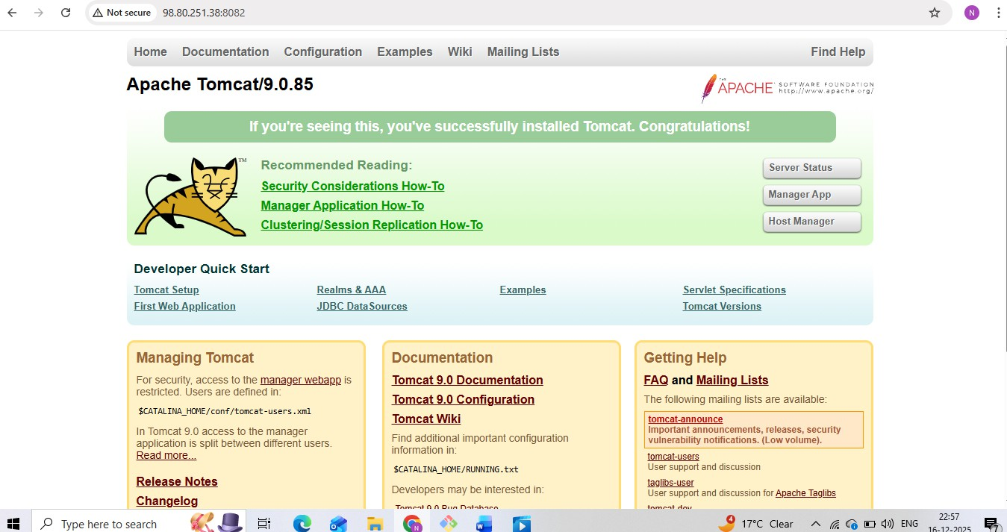
Step 9: check in browser ip address with port number.
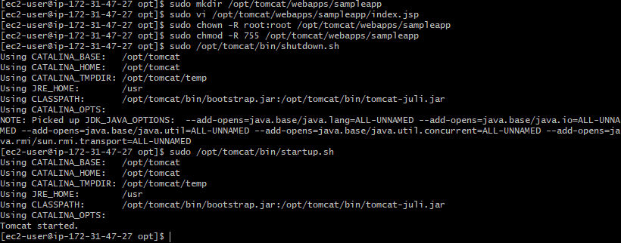
- Deploy a sample app on webapps
  - Step 1:Tomcat expects apps as WAR files or exploded directories under

/opt/tomcat/webapps/sampleapp.
  - sudo vi /opt/tomcat/webapps/sampleapp/index.jsp
  - sudo chmod -R root:root /opt/tomcat/webapps/sampleapp(give permission)
  - sudo /opt/tomcat/bin/shutdown.sh
  - sudo /opt/tomcat/bin/startup.sh
  - tomcat started

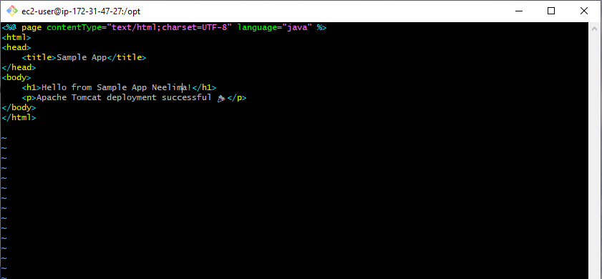
  - Let’s create a simple sample app named sampleapp
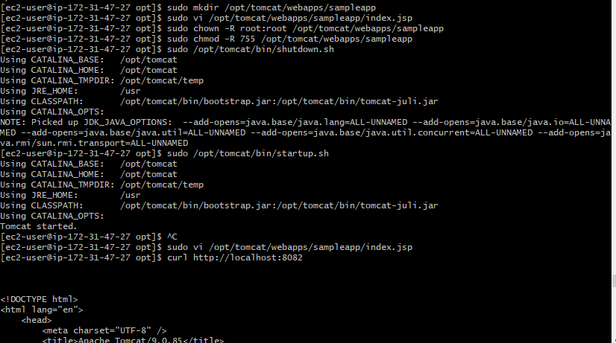
If we are getting errors go through Permissions and check them
- sudo chown -R root:root /opt/tomcat/webapps/sampleapp.
- sudo chmod -R 755 /opt/tomcat/webapps/sampleapp.
- Sudo vi /opt/tomcat/webapps/sampleapp/index.jsp
- Curl http://localhost:8082

After saving the changes of sampleapp file then go the browser check by ip address and file name.

- Create a tomcat.service file for tomcat.

Purpose:
  - Manages Tomcat via systemd: start, stop, restart, auto-start on boot.
  - Ensures proper user permissions and environment variables.

sudo systemctl start tomcat # Start Tomcat sudo systemctl stop tomcat # Stop Tomcat
sudo systemctl enable tomcat # Auto-start at boot sudo systemctl status tomcat # Check status
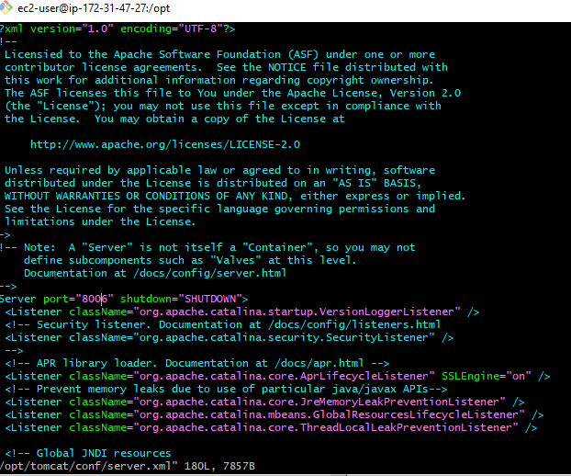
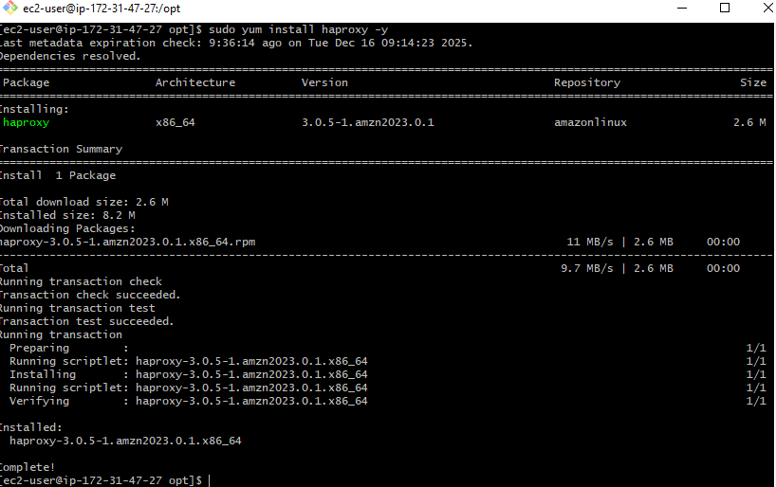
- Configure HA Proxy server

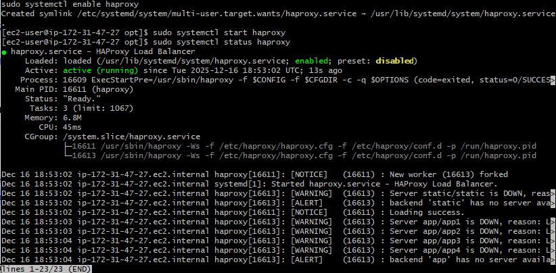
Step 1:sudo yum install haproxy -y

Step 2: Enable and Start HAProxy sudo systemctl enable haproxy sudo systemctl start haproxy
sudo systemctl status haproxy

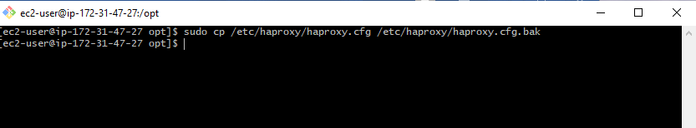
step 3: Backup Original Config
sudo cp /etc/haproxy/haproxy.cfg /etc/haproxy/haproxy.cfg.bak

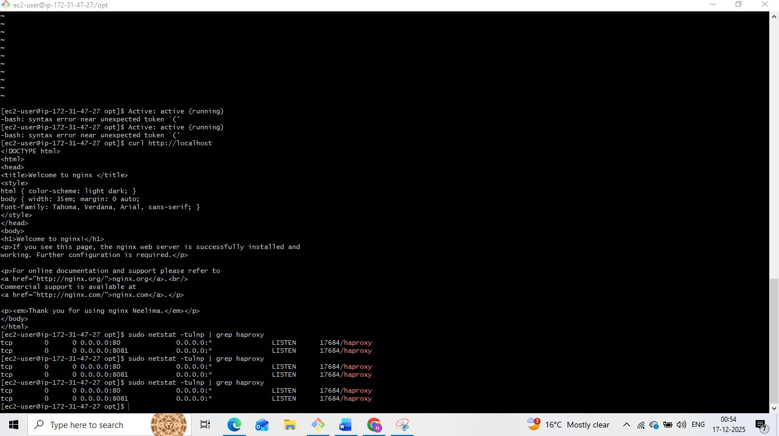
curl http://localhost
Allow port 8081 in EC2 Security Group sudo netstat -tulnp | grep haproxy

